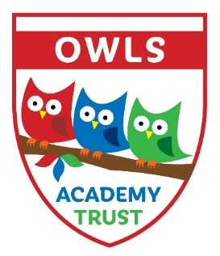
Tay Road, Lubbesthorpe, Leicestershire, LE19 4BF

Oadby Wigston and Leicestershire Schools Academy Trust
OWLS Academy Trust
8th March 2023
Dear Parent/Carer,
Academy News
We would like to inform you that we have now received confirmation from the Department of Education that the OWLS Trust has been chosen and given Secretary of State approval to open a new primary school for a new housing development in Hinckley, Leicestershire. This follows our success in opening an already thriving new school for the growing New Lubbesthorpe community.
As a result, Hollycroft Primary School will be the eighth school joining the OWLS Academy Trust, comprising of Langmoor, Glenmere, Little Hill, Fernvale, Hinckley Parks, New Lubbesthorpe Schools and Ravenhurst. As we carefully grow as a Trust we are able to offer more and more expertise from one school to another and where appropriate share provision of specialist services. We are very much looking forward to strengthening the well-established partnership that we already have across our schools.
The OWLS Academy Trust will continue to operate as before with our CEO (Chief Education Officer and National Leader in Education), Mr Peter Merry, taking a strategic lead and working in conjunction with Trustees, Headteachers and their staff and the Local Governing Bodies to promote a secure foundation from which to achieve high standards across the seven schools. Mr Peter Merry and Miss Hackett will take a lead with the running of Hollycroft initially and Trust Leaders will be working closely with new staff at Hollycroft Primary School throughout the opening period. Miss Hackett will continue with her duties at New Lubbethorpe.
Each of the Schools will continue to run as they currently are with Headteachers, supported by Deputy Head Teachers and the senior leadership teams at each school, who will be responsible for the overall running and progress of the individual schools. Each school will be overseen by a local governing body which in turn is supported by the Trustees and Members of the Multi Academy Trust. The Trustees are made up from independent professionals and volunteers who include current or former governors from the schools. The Trust operates within rigorous national guidelines and is fully audited each year.
Finally, we would like to thank the many parents, governors and staff who have contributed, either directly or indirectly, to helping us achieve this recognition for our hard work in being selected for this exciting opportunity. There is still much to do and many challenges ahead, but we can move forward together with renewed confidence. By working in partnership, we can achieve exciting and transformational change to provide the very best for our children now and in the future.
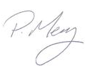
Thank you for your on-going support.
Yours sincerely
Peter Merry CEO, Trust Leader

