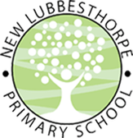
Home Learning
Welcome to your home learning for the week commencing Monday 22nd June! This document outlines all the tasks that should be completed for the week. You should complete the tasks in your exercise book or other paper you have available to you. Please write the date at the top of each page in your exercise book. We would love to see the work that you are completing at home and so if you are able, please send photographs of you completing the tasks, or of the completed page in your exercise book, to the office email address (with the subject ‘FAO Miss Frearson’). Thank you to all those who have sent in work so far: we have loved looking at it and are so pleased that you’re working so hard – keep it up! The tasks can be completed in any order but we recommend that you try and do some phonics and some maths every day to keep up the practice of these key skills.
Remember that there are still lots of links to further work and activities, including the government-backed online learning platform (‘The Oak National Academy), on the ‘Pupil Zone’ area of our website. You can use this at your leisure to supplement and extend your child’s home learning where you wish to. As always, we also encourage story writing, drawing, painting, crafting, physical activities, fine motor skills practice or any other educational activity of your choice! We would love to see photographs of any such activities you complete at home: we can’t wait to see what you’re getting up to! Should you run out of space in your exercise book and require a new one, please contact the office to arrange safe collection. We hope that the instructions here are clear in supporting you and your child at home but do not hesitate to contact us if you require any further assistance.
Home Learning Week Commencing 22.6.20
Phonics: Phase 3 recap.
The five sounds for this week are oo (as in “food”, oo (as in “look”), ar, or, ur. Each day, take one of the sounds and follow the format below to learn the sound. If your child is secure with the phase 3 sounds and can comfortably write words and simple sentences containing the 5 phonemes above, follow the same format but with the following phase 5 sounds, which are all split digraphs: .a-e (as in “cake”), e-e (as in “these”), i-e (as in “slide”), o-e (as in “bone”), u-e (as in “flute”).
- Recap | Practise recall of all other sounds and tricky words using the flashcards you have at home.
- Teach | Introduce the focus sound for today (either oo, oo, ar, or, ur). Say it aloud, say it quietly, say it loudly, say it in a funny voice etc. Look at how the letter should be formed, starting with the whoosh. Write it in the air, on the palm of your hand, on each other’s backs etc. with your “magic finger” (If you’re feeling adventurous, you could write it in shaving foam/the sandpit etc!)
- Practise | Practise writing the sound in your exercise book at least five times (until you can confidently form the letters). Your child may need to start off with tracing your letters before moving on to do their own.
- Apply | Read words with the sound in – you will need to write words for your child to read out. E.g. for ‘ar’, example words would be ‘bar’, ‘hard’ ‘park’ ‘jar’, progressing to ‘harsh’ ‘charge’, ‘shark’, ‘harder’, ‘parking’.  Write the words with the sound in independently.  Write a sentence with the sound in. E.g. for ‘ar’, it could be “The car parks next to the bar”. Encourage your child to write longer sentences using conjunctions if they are able e.g. “The shark can charge and harm the man”. Encourage your child to come up with their own sentence and repeat it aloud several times before they write it to help them remember what they want to write. Reinforce the idea of starting with a capital letter and ending with a full stop.
Maths:
This week, the focus is on counting to 100 in ones and tens. You will need a 100 square. There is one attached at the bottom of this document or, for an interactive one, go to https://www.primarygames.co.uk/pg2/splat/splatsq100.html
Choose from the following activities:
- Use the 100 square to count on in ones to 100, starting from a variety of numbers.
- Look at how the 100 square is organised – from smallest to biggest, from left to right, in lines of 10. Reinforce the idea that 10 rows of 10 makes 100.
- Emphasise the multiples of ten – e.g. when you get to these (10, 20, 30 etc.) at the end of each row, shout them/whisper them/say them in a funny voice. What do they all have in common? They end in a zero and the tens value goes up by one each time.
- Cover up the multiples of ten in the 100 square and then count. Can you remember what numbers are hidden?
- Count in tens from 0 to 100.
- Make sticks of tens using cubes/lego/squares of paper/post-its etc. Shuffle a pack of “cards” with numbers 10-100 written on them and pick one. They must then count in tens to find that number of whatever resources you have used. Count together in tens to check.
- Using the same “cards”, pick one out and your child shows you that number of tens by flashing groups of ten fingers.
- Using the same cards, split them between you and your child. Put one down on the table. You then take it in turns to put down a card but you can only put down a card that is ten less or ten more than the card on the table. E.g. if the starter card is 60, you can only put down 50 or 70.
- Using the same cards, play higher or lower. Shuffle the cards and place the first one down, face up. Guess whether the next card is higher or lower. Place the next card down and see!
- Show children 3 see through bags/containers of either 5, 10 or 15 objects. Ask them to guess whether there are 5, 10 or 20 objects in the bags. They must then take them out and count them to check their estimates. Play with higher numbers of objects if appropriate.
If you are looking for content on shape, space and measure or other content to supplement your child’s home learning, we would thoroughly recommend looking at the Oak Academy website. The following link will take you straight to the maths pages where you can find lessons to support/challenge your child as appropriate : https://www.thenational.academy/online-classroom/reception/maths#subjects (EYFS) https://www.thenational.academy/online-classroom/year-1/maths#subjects (Year 1)

Other Tasks:
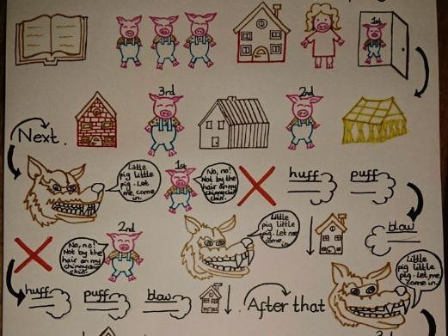
This week, as part of our ‘Traditional Tales’ topic, we are studying the story of “The Three Little Pigs”. This is a well known story that is widely available but there is a version available on the ‘Pupil Zone’ area of the website should you wish to read this one.
Story Map. Discuss the key events in The Three Little Pigs story. Create a story map of the events in the story using pictures and key words like in the example here. Show the flow of the story using arrows. Once you’ve made your story map, retell the story verbally using the story map as your guide.
Write The Next Part Of The Story. Imagine there was a fourth pig in the story. What could he make his house out of? Maybe his house could be a crazy house, made out of weird and wonderful materials! Write about the fourth pig: describe what his house is like and what happens when the wolf pays him a visit.
Junk Modelling. Using resources you have at home (e.g. cereal boxes, egg cartons, kitchen roll holders etc.), construct a house for the three little pigs. Consider how to make it strong so that the wolf cannot blow it down. Write sentences to explain your design and how it will help keep the pigs safe.
Create Artwork Based On The Story. Make a piece of art to show what happens in the story. At school, we are making pigs using our handprint and then creating a house around the pig out of lolly sticks and art straws but it’s up to you how you do this! Be imaginative and show your creativity! Some ideas are below.
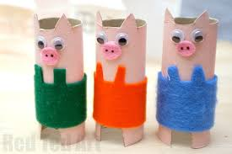
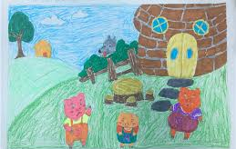
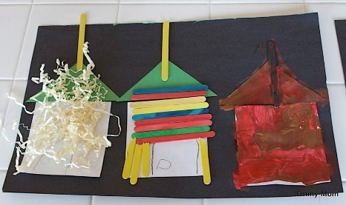

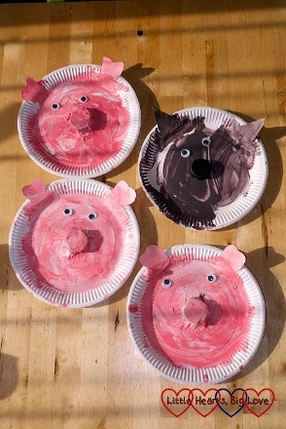
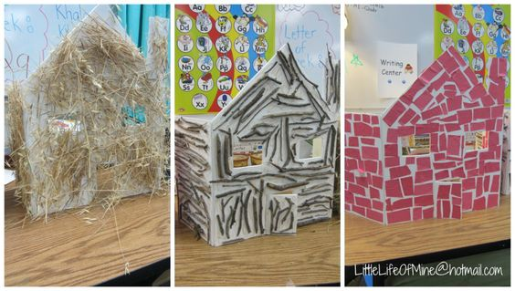

Reading. Remember to keep up the reading on the Oxford Reading Buddy website. We will be reading lots of traditional tales at school this week and discussing their similarities and differences so read stories like “Hansel and Gretel”, “Little Red Riding Hood”, and “The Three Little Pigs” if you can.
Good luck and enjoy your week!
L. Frearson and S. Gittins

