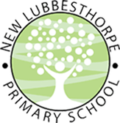

Home Learning

The way in which we are organising our home learning is changing: we will be aligning the home learning with what we are learning in class now that the school is open. Each week, a document like this one will be sent out via the jotter. This document outlines all the tasks that should be completed for the week. You should complete the tasks in your exercise book or other paper you have available to you – printed worksheets will not be required. Please write the date at the top of each page in your exercise book. We would love to see the work that you are completing at home and so if you are able, please send photographs of you completing the tasks, or of the completed page in your exercise book, to the office email address (with the subject ‘FAO Miss Frearson’). You can send these emails daily, as soon as you have finished your work for the day, or, if you prefer, wait until the end of the week and then send all your photographs together. The tasks can be completed in any order but we recommend that you try and do some phonics and some maths every day to keep up the practice of these key skills. Remember that there are still lots of links to further work and activities, including the government-backed online learning platform (‘The Oak National Academy), on the ‘Pupil Zone’ area of our website. You can use this at your leisure to supplement and extend your child’s home learning where you wish to. As always, we also encourage story writing, drawing, painting, crafting, physical activities, fine motor skills practice or any other educational activity of your choice! We would love to see photographs of any such activities you complete at home: we can’t wait to see what you’re getting up to! Should you run out of space in your exercise book and require a new one, please contact the office to arrange safe collection. We hope that this new format is useful and clear in supporting you and your child at home but do not hesitate to contact us if you require any further assistance.

Home Learning Week Commencing 1.6.20
Phonics: Phase 3 recap.
The five sounds for this week are j,v,w,x,y,z. Each day, take one of the sounds and follow the format below to learn the sound. If your child is secure with the phase 3 sounds and can comfortably write words and simple sentences containing the 5 phonemes above, follow the same format but with the following phase 5 sounds: ay, ou, ie, ea, oy.
- Recap | Practise recall of all other sounds and tricky words using the flashcards you have at home.
- Teach | Introduce the focus sound for today (either j, v, w, x, y, z). Say it aloud, say it quietly, say it loudly, say it in a funny voice etc. Look at how the letter should be formed, starting with the whoosh. Write it in the air, on the palm of your hand, on each other’s backs etc. with your “magic finger” (If you’re feeling adventurous, you could write it in shaving foam/the sandpit etc!)
- Practise | Practise writing the sound in your exercise book at least five times (until you can confidently form the letter). Your child may need to start off with tracing your letters before moving on to do their own.
- Apply | Read words with the sound in – you will need to write words for your child to read out. E.g. for ‘v’, example words would be ‘van’, ‘vet’, progressing to ‘visit’, ‘Kevin’, ‘velvet’.  Write the words with the sound in independently.  Write a sentence with the sound in. E.g. for ‘v’, it could be “The vet had a pet dog”. Encourage your child to write longer sentences using conjunctions if they are able “The vet had a pet dog and she was poorly”. Encourage your child to come up with their own sentence and repeat it aloud several times before they write it to help them remember what they want to write. Reinforce the idea of starting with a capital letter and ending with a full stop.

Maths:
We will now be using Numberblocks resources through the link https://www.ncetm.org.uk/resources/52060. We are starting from series 2 episode 1 so scroll down to find the correct lesson. This means that this week, if you do maths every day as recommended, you should cover episodes 1-5. Open the PowerPoint for the correct lesson. It will ask you for a password but just click “read only” and the lesson will work. Use the adult prompts and the notes at the bottom of the PowerPoint to help guide you. You will need to find the corresponding Numberblocks video for each lesson on BBC iPlayer where they are all available to access for free. N.B the second part of the PowerPoints focus on Year 1 content. For these maths activities, it often refers to using your ‘Numberblock linking cubes’. If you do not have maths cubes at home, you may need to make something to represent the numbers or use Lego/Duplo etc. like in the images below. The Numberblocks lessons focus on number and counting within 10 to begin with; if you are looking for content on shape, space and measure or numbers beyond 10 to supplement your child’s home learning, we would thoroughly recommend looking at the Oak Academy website. The following link will take you straight to the maths pages where you can find lessons to support/challenge your child as appropriate : https://www.thenational.academy/online-classroom/reception/maths#subjects (EYFS) https://www.thenational.academy/online-classroom/year-1/maths#subjects (Year 1)
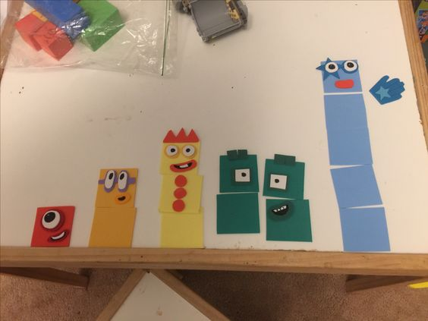
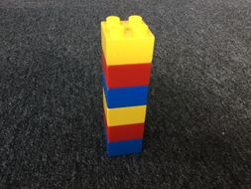

Other Tasks:
Make a poster. Recap the importance of washing our hands and how we can stay safe from the spread of germs (i.e. by using tissues when we sneeze, by staying our distance from people we don’t live with). Make a poster to show this information. Include a title (e.g. “Wash your hands”), some illustrations and written instructions. Encourage your child to use their phonics to write their captions and sentences. Decorate your poster to make it eye-catching.
Make a germ. Use craft materials to make a baddy germ. Cut him out to practise your cutting skills. Can you give him a name and write a sentence how you made him?
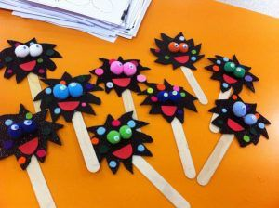
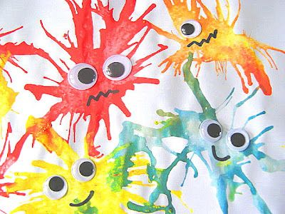

While We Can’t Hug Activities. Watch the video “While We Can’t Hug” on YouTube: https://www.youtube.com/watch?v=2PnnFrPaRgY (You will need to read the words aloud for your child to understand). Discuss what the story is about and why it is important to us – because we can’t hug our friends either! In what ways did the hedgehog and the tortoise show their friendship instead? We have lots of friends/relatives that we are not able to see or play with at the moment. How can we show them that we love them and we miss them?
- Make a picture for a friend/relative. Use paints or crayons to make a picture to cheer them up. Could you include pictures of their favourite things?
- Write a letter to a friend/relative. What does a letter normally start with? (Dear…) What would we like to say to our friends? (that we miss them but we have been up to lots of cool things such as…) What must we remember when we are writing? (finger spaces, capital letter to start sentence and full stops to end, use our phonics etc.)
- Practise singing a song to perform to a friend/relative. (Consider videoing this and sending to a relative/the school!)
- Anything else your child would like to make/do/write to show their friends/relatives that they care about them.

Good luck and enjoy your week!

L. Frearson and S. Gittins

