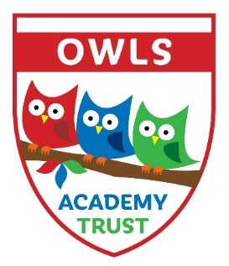
Kenilworth Drive, Oadby, Leicestershire, LE2 5HS

Oadby Wigston and Leicestershire Schools Academy Trust
OWLS Academy Trust

Coronavirus: required closure – letter

Dear Parents/Carers,
Re: Coronavirus update – school closure to most pupils

Following on from my last update, I’m writing to let you know that we have now been instructed to close the school to almost all children after this Friday until further notice.
As advised by the government, we will do all we can to stay open for the children of key workers (e.g. NHS staff, police, others in frontline services) and children with certain needs.
We are waiting for the government to publish more information on what this means, but it would help us in the meantime if you could let us know if you think your child may fall into one of these categories.
Please could you email office@newlubbesthorpe.leics.sch.uk today to support our organisation of this matter, completing the box below:
Childs Name | Parents Name | Job | Contact number if Changed | Email address if changed

We’ll be in touch again as soon as we are sure who this does apply to.
All other children will need to stay at home, so we ask that you do not send your child into school from Monday onwards.
Please note that this is a national closure – as you may have heard in the news – so while it is a challenging situation, we are not alone. We’ll re-open fully as soon as we can and will let you know when this is by Text, email or our school websites.

What we’ll continue doing while your child is at home
Your child’s learning is of course important to us, so we’ll continue to help your child to learn. This will be done via our school website, within the Pupil Zone section and via work Packs sent home. Next week’s work is already uploaded for you. Please use the link: https://www.newlubbesthorpe.leics.sch.uk/pupil-zone
If your child usually receives free school meals we will also be in touch with more information about how we will continue to provide this, with support from a scheme that the government has just announced.

What we won’t be able to go ahead with
- School trips
- Breakfast or after-school clubs
- Events
- Internal exams or tests (Including SATs)

This is as much as we know right now and we appreciate your continued patience with as we deal with this ever-changing situation. We understand that this latest news will have an impact on you and your family and it’s far from ideal, but we’ll continue to keep in touch with any updates as the situation develops.
If you want to get in touch to share any concerns, please don’t hesitate to do so via office@newlubbesthorpe.leics.sch.uk.

And remember: if you or your child feels ill and you want to know what to do next, please use NHS 111 online.
Thank you again for your continued support, and we will be in touch with more information when we can.
Take care and please look after each other.
Yours sincerely

Peter Merry
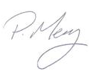
CEO OWLS Trust.

