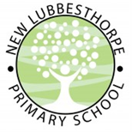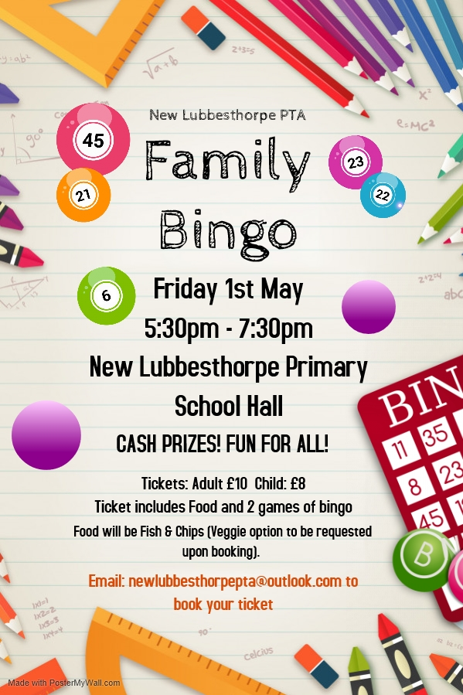

**Family Bingo Night**

Join us for an evening of fun with your families on Friday 1st May. We will play two adult games of bingo and two children’s bingo games.

Included in your ticket is food which will be served halfway through the evening. Food will be fish and chips with all the classic accompaniments…beans, mushy peas and gravy!

On the night we will have soft drinks available to purchase and we will also have a small raffle. Colouring/activities will also be on tables for the children.

Now getting to the good stuff…the prizes!

We will have cash prizes for the adult games. £10 for 1 line, £15 for 2 lines and £25 for a full house. Children’s games will be prizes not cash. These are to be confirmed on the night.

We only have limited tickets available so please book early to avoid disappointment.

This is a family event so siblings are permitted as are aunts, uncles, grandparents and anyone else you want to bring along!

To book your tickets please email: [newlubbesthorpepta@outlook.com](mailto:newlubbesthorpepta@outlook.com)

Please include the number of adult and children’s tickets within your email and please specify any dietary requirements.

We hope to see you there and good luck!